**Transformer:**

* Saturation equation

$\int_{0}^{T/2}{}V_{pk}sin(2πft)dt=\frac{V_{pk}}{πf}$

$\frac{V_{pk}}{πf}=λ_{1}(Volt-seconds)$

$\frac{V_{pk}}{πf}<n*2ΔB*A_{c}$

Peak Flux Density

B = 200 mT

162 mm^2 = 0.000162 m^2

61V Peak

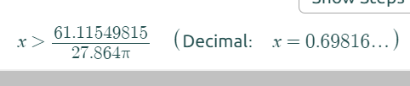

178V Peak

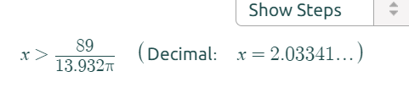

**Inductor:**

* Inductance equation

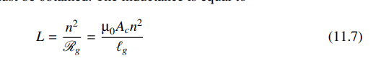

$\frac{μ_{0}A_{C}n^{2}}{{2l}_{g}}$

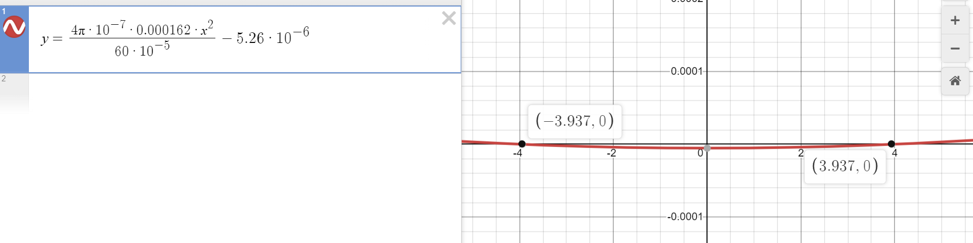

About 8 pieces of paper

4 turns appromximately

* Saturation equation